The Boys of St.Columb's

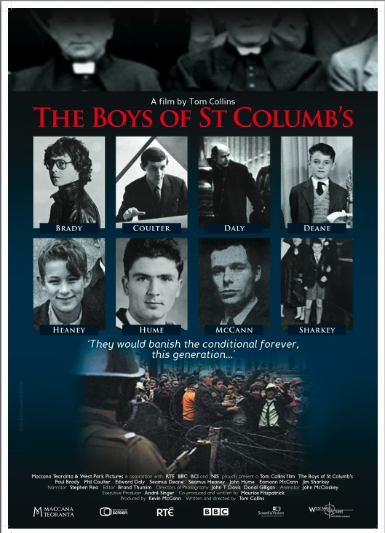

(Ireland/UK / 1-hour documentary / 2010 )

http://www.bbc.co.uk/programmes/b00rfqgd
Produced by Maccana Teoranta & West Park Pictures, London
Documentary film for RTÉ & BBC following the lives of several great Irish figures, including Nobel Laureates Seamus Heaney and John Hume, who have helped transform modern Ireland and who all attended the same small school in Derry in the 1950s.
Featuring the story of Paul Brady, Phil Coulter, Edward Daly, Seamus Deane, Seamus Heaney, John Hume, Eamonn McCann and James Sharkey.
This documentary film tells the story of seven men who started out in St. Columb’s school in Derry City. Born around the second-world war, they knew fear and segregation as young boys. Their circumstances forced them precociously to consider their downtrodden status.
Looking to education, they saw the one thing that would raise them out of their oppression. This education would lead them to become some of the most important figures in Irish culture in recent history.
Apart from surface similarities of creed and background, there is much in these men that points to a deeper unity – which is the main contention of the film: that this generation is unique and distinct as a result of its time and place.

CREATIVE TEAM:
Producer: Kevin McCann
Director: Tom Collins
Narrator: Stephen Rea
Executive Producer: Andre Singer
Co-producer / Writer: Maurice Fitzpatrick
Director of Photography: John T Davis & Donal Gilligan
Animation: John McCloskey, The Nerve Centre, Derry
Editor: Brand Thumim
Composer: Nicholas Singer

