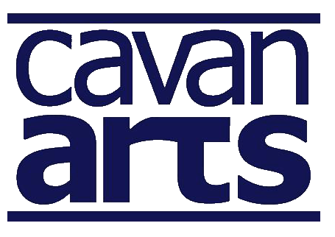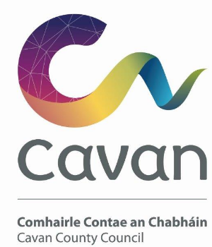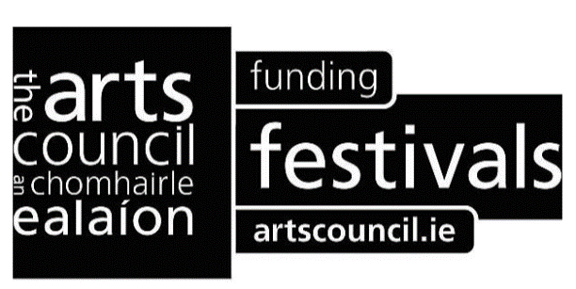

Arts Development Awards 2018 Recipients

Recipient | Amount Awarded | Event / Project
Kate Ennals | €550 | Contribution towards ‘AT The Edge’ 2018 literary evenings.
Aisteoirí Muinchille | €600 | Produce and perform three Brien Friel plays and participate in Dermot Healy interpretation event.
Cavan Down Syndrome Branch | €550 | Arts aimed at pre-school level children to enhance and develop fine motor skills.
Windows Publication | €900 | Support towards Windows Publications 2018 poetry for students.

Positive Age Ltd | €200 | One day celebrations of arts with participants including: music, songs, dance, drama, comedy, poetry and storytelling.
Shercock Drama Festival | €600 | Funding towards the 35th annual drama festival.
The Virginians Drama Group | €300 | Produce and perform Juno and the Paycock by Sean O’Casey.
Castletown Accordion Orchestra (ACCORA | €300 | Mid-summer classical concert in Ramor Theatre.
Kingscourt Youth Drama Society | €750 | Drama workshops including mime, improvisation dialogue, voice projection and stage management.
The Open Door Sessions | €650 | Monthly arts gathering in Bailieborough with established local artists.
Killnaleck Youth Drama Society | €750 | Produce and perform ‘Cybergossip’ new play ‘Alice in Wonderland’ and ‘Stone Soup’.

Theatre Lab Cavan | €600 | Workshops exploring theatre disciplines and acting techniques in conjunction with Ramor Theatre.
St Patrick’s National School – Shercock | €500 | Arts in education project in the school.
Lit Lab Writers Group | €500 | 5th annual Bailieborough Poetry Festival.
Bailieborough School of Music | €300 | Performance in DCU to celebrate 30th Anniversary.
Cavan Drama Festival Committee | €600 | Funding towards the 72rd annual drama festival.
Killinkere Drama Group | €300 | Produce and perform a play by local playwright Pat Clarke.
Gonzo Youth Theatre | €750 | Produce a stage production for 11-13 age group.
Ballyhaise Community Pre-School | €500 | Introducing 2-5year-olds to developmental dance and drama developing creativity, confidence and self-esteem.
Ramor Playwriting Group | €400 | Workshop with Louise Lowe, Anu Productions exploring site-specific work and audiences engagement.
Castlemanor Choir Group | €200 | Performance at local nursing homes.
Gerry Whelan 14th Annual Memorial Weekend | €300 | Funding towards the 3 day event including concert, ceili's, workshops and Irish language comhra sessions.
Tony Cuckson | €300 | "Songs for the Journey Home", performance and workshop at Loughan House.
The Moogles Theatre Company | €500 | New writing by women for theatre.
Lower Lavey Community Group | €600 | Developing local youth in creative practice.

Ed Reavy Traditional Music Festival | €700 | Funding for 4th Ed Reavy Traditional Music Festival incorporating Dancing in the Drumlins at Cavan Crystal, The Backyard Arts and Culture Centre, and The Meadow View Inn. To include a CD launch, concert, music workshops, comhrá workshop, dance
Cavan Camera Club | €500 | Funding towards background kit to use at workshops
Robbie Perry | €714 | One day workshop for 12 students in Cootehill library
Cootehill Arts Festival | €1000 | Funding towards the Cootehill Arts festival 2018.

