Cavan County Council
ARTS DEVELOPMENT AWARDS

Guidelines and Application Form for Arts Providers
For projects and events taking place up to February 2019
Deadline for submission of completed application: 25th January 2018

Organisations, groups or individuals running arts events and projects in County Cavan or promoting the County arts offerings elsewhere between February 2018 – February 2019.

Criteria
The Arts Developments Awards are designed to assist and enhance arts participation, engagement, and audience development for the arts in relation to any of the following categories:

Arts Participation (e.g. workshops, performance, arts production, etc. involving the general public and/or target groups)

Arts in Settings (e.g. Artist-led projects in settings such as community, education,
health care, landscape, etc.)

Arts Events (e.g. stand alone events, events as part of a festival, scheme or
community project, etc.).

The examples above are meant as a guide only. The scheme is open to other proposals that arts providers might wish to make which are relevant to their aims.

Please Note
- The total funds available under this scheme will not exceed €12,000.
- Applicants are encouraged to source funding from other agencies or sponsors.
- The maximum amount awarded to any applicant will be €1,000, however it is expected that most awards will be in the region of €400 - €600.
- The assessment and quality of your application will be adjudicated by a panel.
- Applicants are notified approximately six weeks after the closing date.
- Applications in hardcopy only: support material is essential to each application.
- Late applications cannot be accepted.
- Closing date is: Thursday 25th January 2018 at 4.00pm

Arts Development Awards Application Form

Name of Individual, Group or Organisation:
Name of Secretary if different from above:
Contact Address (all correspondence will be sent to this address)
Tel | Mob
Email | Web: www
Please give a short description of your proposal (max 100 words)

1. Please detail the structure of your organisation e.g. not-for-profit, private company, organisation with constitution, etc. Or in the case of individual or community group outline roles in respect of activities and any support structures already in place.

2. Please provide project details. This may include activities, number of artists and participants, location, timeline, marketing plan, and other relevant information (use additional sheets if needed).

3. Please describe how this Award would contribute to arts development. This may include project objectives and/or mission statement, target groups, quality of engagement, etc.

Supporting Documentation | Please Tick
CDs / DVDs and/or appropriate links*
Biographies of Artists and/or Arts Specialists (CV’s may be requested if successful)
Other (programmes, photographs, catalogues and other printed or published advertising, promotion of the arts*
Please do not include original items as they cannot be returned.
Applicants working with children must demonstrate that they have or are in the process of obtaining Garda Clearance (in the case of artists and facilitators), or a Child Protection Policy (in the case of an organisation).
If you are organising an arts festival or public event please indicate if you have a Health and Safety Plan in place.

* This information should demonstrate your track record in arts development, and
acknowledge the support of your funders where applicable.

Supporting documentation must be included for the assessment of your application. If you have previously received funding from Cavan County Council or other funding agencies, please include examples with your application of how you acknowledged this funding i.e. posters, press, tickets, programmes, web links, etc.
Financial Information
Please estimate your budget breakdown
Projected Income | €
Sponsorship
Grant aid
Ticket sales
Sale of product
Income in kind
Other Contributions
Requested Amount from Cavan County Council
Total Income | €
Projected Expenditure | €
Artist Fees
Other Fees (e.g. other professionals, service providers, etc.)
Materials
Advertising
Administration
Travel
Subsistence
Insurance
Rent
Utilities
License/Rights
Other
Total Expenditure | €

Bank Details
Name of Account:

IBAN
BIC
Bank Name:

Bank Address:

Currency:

Your application will be adjudicated using the following criteria and weighting:

- Experience and track record of artists, and team where applicable 15
- Benefits to ongoing arts and audience development 15
- The quality of the proposal 25
- The quality of the proposed project 25
- The Impact of the project on the wider arts environment in County Cavan 20

The completed application and documentation should be addressed as follows:
The Arts Office, Cavan County Council, Farnham Centre, Farnham Street, Cavan, H12 C9K1
Closing date for the receipt of completed applications is
Thursday 25th January 2018 at 4.00pm

Please note that applications received after the closing date and time cannot be accepted.

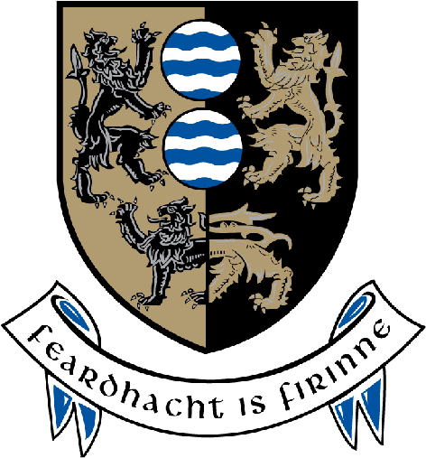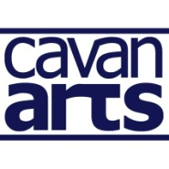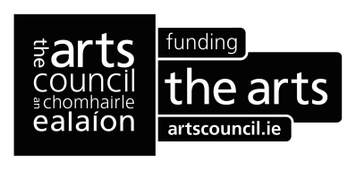

For Office Use Only
Date Rec. | A.O. Recm. € | Co. Co. Approval
Ref. No. | Date | Date
Signed | Signed | Signed

Response Date | Payment Requested | Payment Sent/Paid
Signed | Date | Date

