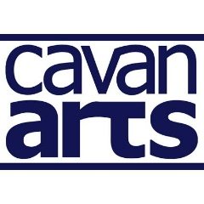
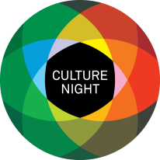
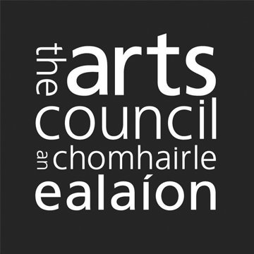
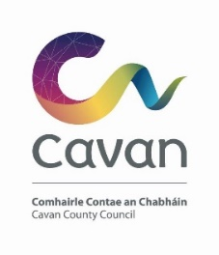

County Cavan Culture Night 2022- Open Call

Cavan County Council are pleased to confirm that Culture Night will take place on Friday September 23rd, 2022, from 4pm till late and are looking for expressions of interest to participate. Culture Night is an annual all-island public event that celebrates culture, creativity, and the arts. On that evening venues and events are available to the public free of charge.
There will be three main strands under which Cavan County Council will programme free events across the county.

These will focus on:
- A diverse programme for all ages, including family friendly events that can include but are not limited to architecture, design, languages, heritage, environment, and the arts. (4pm - 8.30pm).
- Heritage programme - we are looking for specific proposals from organisations and creative practitioners operating in any discipline to propose an event that interacts with Co. Cavan’s natural, built, and cultural heritage.
- New Voices programme - we are looking for events that celebrate new communities and underrepresented voices. Events should promote and connect artists from marginalised backgrounds and showcase the culturally diverse communities living in the County. We would love to hear from any community, and particularly welcome applications from the Traveller community, new communities and the LGBTI+ community.

Priority will be given to projects that fulfil at least one of these criteria:
- that consider culture and creativity in a wide sense to include underrepresented cultural expression and new voices.
- that are of high artistic ambition, with cognisance for inclusivity, sustainability and accessibility, in line with the Arts Council Equality, Human Rights and Diversity Policy.
- that encourage more people to visit cultural venues, learn about local heritage and experience culture in their locality.
- that respond creatively to the programme strands as outlined above.

We will be funding several key events €100 - €1,000 across the County that engage directly with the priorities of Culture Night as outlined above. It may not be possible to offer funding to all applicants and it may also not be possible to offer the full amount requested to any individual applicant. Please ensure that all relevant information is included in your application, including the proposed budget for the event.
If you have queries about the application process, please contact:
Danielle McDermott directly: dmcdermott@cavancoco.ie.

Covid 19
In 2022 Covid 19 continues to require us to adapt. Therefore, we are asking groups/individuals to consider and submit innovative contingency plan for their projects/s should there be further Lockdowns. Applications will be reassessed for suitability based on public health guidelines should this be necessary.
The closing date for receipt of submissions of interest is Thursday July 21st at 5pm.

PART A: Group/Organisation/Individual Information
Name
Email
Phone
Website or social media
Please indicate by highlighting the box which category you/your organisation comes under:
Voluntary/Local Community Arts | Professional Arts | Non-Professional Arts

PART B: Outline of Proposed Project for Culture Night 2022

Under which programming strand are you applying? If your application spans across two strands, please identify both strands.
GENERAL PROGRAMME (4 - 8.30PM)
All ages, including family friendly events
HERITAGE PROGRAMME
NEW VOICES PROGRAMME

Please provide essential information about the proposed project, including your target audience, location, event management and proposed timing in the event description where appropriate.

Essential Information
Target Audience
Location
Event Management
Proposed Timing

2022 may bring more Covid 19 lockdowns, therefore we are asking groups/individuals to submit innovative contingency planning for their projects/s (reducing audience size/ticketing/online or hybrid programme)
How does your proposal reflect the priorities for Culture Night 2022?
Please note you only need to fulfil one priority. Select the one the suits your proposal best.

Health and Safety Compliance
It is a condition of funding that you have a risk assessment method statement including an event plan in place for your culture night event(s).

Useful resource - https://www.besmart.ie/

Confirm that you will seek any necessary permissions, licences as appropriate
i.e., the use of a local authority space.

PART C: Support Fund
Please provide a breakdown of costs that apply to your event(s).
Please include in kind costs where appropriate.
Artist Fees (Details, please)

Direct Activity Costs (Event Insurance, materials, transport, Admin)

Equipment Costs (including hiring of technical expertise and equipment)
Other Costs (Details, please)

Name of your Insurer
In Kind costs

Total Costs

Amount of Funding Sought

Please also include:
- one photo that represents your proposal to be used for marketing purposes. (This is ESSENTIAL)

We will only use the personal data supplied for the purposes of the Culture Night 2022 application process and your application details will be deleted once the application process is completed. Please contact us if you wish to obtain further information concerning our retention periods and you have the right to withdraw your application details at any time.

Please return to Danielle McDermott, dmcdermott@cavancoco.ie by 5pm on Thursday July 21st.
Late Applications will not be accepted.

