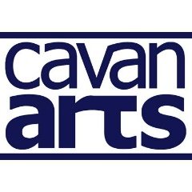
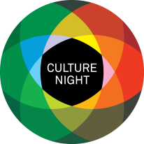
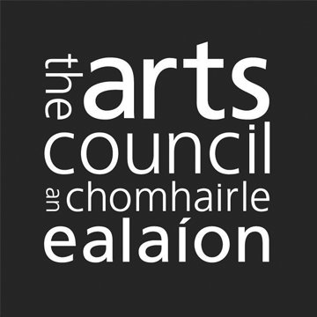
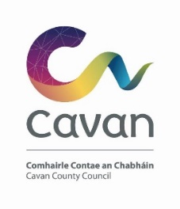

County Cavan Culture Night 2023 - Open Call

Cavan County Council are pleased to confirm that Culture Night will take place on Friday September 22nd, 2023, from 4pm till late and are looking for expressions of interest to participate. Culture Night is an annual all-island public event that celebrates culture, creativity, and the arts. On that evening, venues and events are available to the public Free of Charge.
Culture Night / Oíche Chultúir is brought to you by the Arts Council; it is a national moment, celebrating culture, creativity and the arts and seeks to actively promote the belief that this rich and varied culture is alive, treasured and nurtured in people’s lives, today and every day. It is delivered nationwide in cities, towns, villages, and rural locations as well as online and through our media partners.
742,000 people across the country engaged with 1,700 Culture Night events in 2022.

Priority will be given to projects that fulfil at least one of these criteria:
- that consider culture and creativity in a wide sense to include underrepresented cultural expression and new voices.
- that are of high artistic ambition, with cognisance for inclusivity, sustainability and accessibility, in line with the Arts Council Equality, Human Rights and Diversity Policy.
- that encourage more people to visit cultural venues, learn about local heritage and experience culture in their locality.

We will be funding several key events to the amount of €100 - €1,000 across the County, that engage directly with the priorities of Culture Night as outlined above. It may not be possible to offer funding to all applicants and it may also not be possible to offer the full amount requested to any individual applicant. Please ensure that all relevant information is included in your application, including the proposed budget for the event.

If you have queries about the application process, please contact:
Danielle McDermott: dmcdermott@cavancoco.ie

Please return to Danielle McDermott, dmcdermott@cavancoco.ie by Thursday July 6th at 5pm.

PART A: Group/Organisation/Individual Information
Name
Email
Phone
Website or social media
Please indicate by highlighting the box which category you/your organisation comes under:
Voluntary/Local Community Arts | Professional Arts | Non-Professional Arts

Please provide essential information about the proposed project, including your target audience, location, event management and proposed timing in the event description where appropriate.

Project Proposal
Target Audience
Location
Event Management
Proposed Timing

Health and Safety Compliance
It is a condition of funding that you have a risk assessment method statement including an event plan in place for your culture night event(s).

Useful resource - https://www.besmart.ie/

Confirm that you will seek any necessary permissions, licences as appropriate.
i.e., the use of a local authority space.

PART C: Support Fund
Please provide a breakdown of costs that apply to your event(s).
Please include in kind costs where appropriate.
Artist Fees

Direct Activity Costs (Event Insurance, materials, transport, admin)

Equipment Costs (Including hiring of technical expertise and equipment)
Other Costs

Name of your Insurer
Total Costs

Amount of Funding Sought

Please also include:
- one photo that represents your proposal to be used for marketing purposes. (This is ESSENTIAL)

We will only use the personal data supplied for the purposes of the Culture Night 2023
application process and your application details will be stored until the final reporting is completed. Please contact us if you wish to obtain further information concerning our retention periods, and you have the right to withdraw your application details at any time.

Please return to Danielle McDermott, dmcdermott@cavancoco.ie by Thursday July 6th at 5pm.

Late Applications will not be accepted.

