Cavan County Council Arts Office

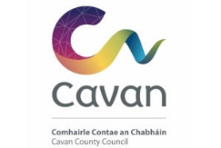
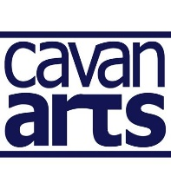

DRAMA LEAGUE OF IRELAND SCHOLARSHIP

Cavan County Council Arts Office is pleased to announce the provision of two full scholarships in 2024 for the Drama League of Ireland Residential Summer School which takes place at the University of Limerick from 20th to 27th July 2024.

The Drama League of Ireland (DLI) is the national representative body for amateur drama groups, societies, and individuals. The Summer School facilitates participant’s artistic development by furthering their knowledge and experience with other professionals involved in the theatre-making world.

The scholarship will cover the cost of a residential place at the Summer School and includes tuition, accommodation, and meals.
N.B. you must already be booked onto a course.

Selection Criteria

- Artistic Merit
- Clarity regarding expectations
- Geographic distribution of theatre group applicants
- Impact / wider benefit

TERMS, CONDITIONS AND GUIDELINES

- Completed applications must be submitted by email to dmcdermott@cavancoco.ie (please note -15 MB maximum size per application). Please put in the subject Line of the email –

‘Drama League of Ireland Scholarship 2024 – (and your name)’

- Applicants must be currently residents in County Cavan.

- The bursary award applies to the Drama League of Ireland Summer School which takes place.
in the University of Limerick from 20th - 27th July 2024. Candidates must be available to attend on these dates.
N.B. you must already be booked onto a course.

- The bursary will cover course fees, including tuition, single room en-suite accommodation, meals, and social programme.

- The bursary does not include travel expenses, and candidates must make their own travel arrangements.

- Cavan County Council reserves the right to publicise the awarding of the D.L.I. Bursary.

- No cash alternative will be offered.

- The bursary cannot be passed on to a third party.

- Candidates must be over 18 years of age on 14th April, 2024.

- Grant aid provided by Cavan County Council must be acknowledged in all publicity material associated with the project.
- Successful candidates must provide a short-written report to the Arts Office on completion of the project.

- Awards will be made by an independent adjudication panel.

- All applicants will be advised of Council’s decision by email.

- Hard copy, late or faxed applications will not be considered.

Further details about the Drama League of Ireland can be found on www.dli.ie, or Tel: 01-2969343.

Contact: Danielle McDermott, Cavan County Council Arts Office.
Tel No. 049 4378549/dmcdermott@cavancoco.ie.

CLOSING DATE FOR RECEIPT OF APPLICATIONS IS
on or before 4pm on Friday 26th April 2024

Please email completed application form with supporting documentation – (please note - 15 MB maximum size per application) to dmcdermott@cavancoco.ie

Please put in the subject Line of the email: ‘Drama League Of Ireland Scholarship 2023 – (and your name)’

.

Drama League of Ireland Residential Summer School
Sat 20th to 27th July 2024, University of Limerick
SCHOLARSHIP APPLICATION FORM

Cavan County Council Arts Office is pleased to announce the provision of one scholarship for amateur drama enthusiasts in County Cavan to attend The Drama League of Ireland Summer School.

Name ______________________________________________________________________

Address ____________________________________________________________________

____________________________________________________________________________

Contact Telephone No _______________________________________________________

Email _______________________________________________________________________

Drama Group ________________________________________________________________

Outline your previous drama experience. Max. 100 words

_____________________________________________________________________________
_____________________________________________________________________________
________________________________________________________________________________________________________________________________________________________________________________________________________________________________________________________________________________________________________________________

Outline drama training if applicable. Max. 100 words __________________________________________________________________________________________________________________________________________________________________________________________________________________________________________________________________________________________________________________________________________________________________________________________________________________________________________________________________________________________________________________________________________________________________

Please outline the reasons why you wish to attend the DLI Summer School and identify benefits for you and your drama group. Max. 200 words

______________________________________________________________________________________________________________________________________________________________________________________________________________________________________________________________________________________________________________________________________________________________________________________________________________________________________________________________________________________________________________________________________________________________________________________________________________________________________________________________________________________________________________________________________________________________________________________________________________________________________________________________________________________________________________________________________________________________________________________________________________________________________________________

Why do you deserve this award? Max. 50 words

__________________________________________________________________________________________________________________________________________________________________________________________________________________________________________________________________________________________________________________________________________________________________________________________________________________________________________________________________________________________________________________________________________________________________

SIGNED _____________________________ DATE ___________________________

Submission of application form implies acceptance of the terms and conditions of the scheme.
Completed applications must be submitted by email to dmcdermott@cavancoco.ie (please note
15 MB maximum size per application) on or before 4pm on Friday 26th April 2024

Please put in the subject Line of the email –

‘Drama League Of Ireland Scholarship 2024 – (and your name)'

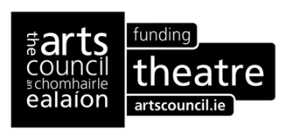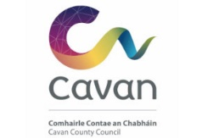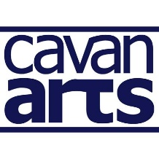

To find out more about these courses visit https://www.dli.ie/summerschool

