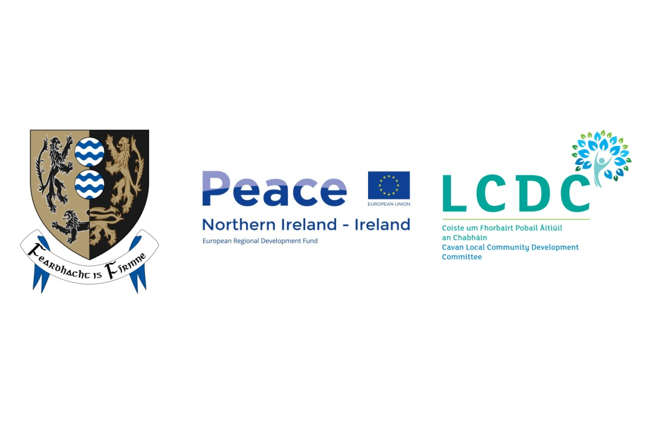Cavan County Council

Request for Quotations for

Art Form Facilitators Peace IV for Cavan Youth Arts Lab

Vacancies have arisen for an art form facilitator for Peace IV for a new project entitled Cavan Youth Arts Lab at Cavan Arts Office. Successful facilitators will be established, community arts facilitator with strong art form expertise, youth and community arts experience and proven track record to deliver within a time frame. The facilitators will work with children, teenagers and young adults and will be experienced working with these age groups and have an understanding and awareness of Child Protection and work for the best interest of children. Art Form areas will include: graffiti art, dance and music.
There are specific requirements for each of these art forms. Artists may apply for one or more of these art form disciplines. Information on how to apply for each art form is detailed below and a separate application will be required for each art form being applied for.
Project Outcomes:
This project will enhance the capacity of children and young people to form positive relationships with others irrespective of their background. It will support their development to make a positive contribution to a more equal society. The various arts practices that the young people will engage in will encourage them to think and question beyond their own community and experience.

The project will enhance self confidence and self awareness leading to respect for self and others. The project will enhance problem solving through developing visual, literal, aural and spatial awareness by this sustained approach. It will support a greater understanding of diversity. It will develop community relations through engagement work that includes workshops, events and exhibitions in community contexts. It will support young people to have quality arts experiences both as makers and audiences.
Project Objective

Cavan Youth Arts Lab will provide specialist youth arts programmes where young people from cross community and cross border backgrounds can work together, are valued and encouraged in their creativity, and can be part of making exciting production processes that create profound cultural memory.
Cavan Youth Arts Lab will focus on the cultural development of children and young people and will work with young people from age 8 to 18 years and support them to make art work in their diverse communities. The programme will support children and young people from different backgrounds to work together. It will further support young people to work in context with adults where appropriate to create new work. The core values of this project are inclusivity and participation.

Essential Requirements For each Art Form

All Successful Facilitator(s) MUST comply with Cavan County Council Insurance, Tax Clearance, Garda Clearance, Bona Fides and Health and Safety Requirements and this will be essential before any contract is entered into.

Insurance

All Successful Facilitator(s) will be required to provide Cavan County Council with evidence of Insurance Cover to incIude: employers’ liability and public liability. Employers Liability of €13,000,000 (only required if the facilitator has employees) and public liability of €2,600,000 will be required.

Garda Clearance,

All Successful Facilitator(s) will be garda vetted and must adhere to Cavan County Council Child protection policy and be familiar with Children’s first National Guidelines for the protection and welfare of children.

Tax Clearance

All Successful Facilitator(s) MUST be tax compliant. Cavan County Council can verify your tax clearance status through Revenue’s online facility at http://www.revenue.ie/en/online/tax-clearance.html.

Health and Safety

All Successful Facilitator(s) MUST must comply with the Safety Health & Welfare at Work Act 2005 and must comply with Cavan County Council Health and Safety Requirements.

Timeframe

The Youth Arts Lab is a two year Peace funded project and it is anticipated that the outcomes will continue after this period. This phase of the overall project is expected to take place between June and December 2018 and the project concludes in September 2019. Delivery will take place outside the formal education system during term time and during holiday times for intensive work. Successful arts facilitators will agree in advance time table and workshop schedule and this can be amended / cancelled at the discretion of the employer.

Awarding the contract;
All Applicants must submit a Response Document for the Art Form they are interested in applying for.

Applications must be valid and compliant. This means the application must contain the correct documents, in the correct format (not altered) and be submitted to the correct email address no later than the RFQ Response deadline.

Only compliant Applications will be evaluated under the following Criteria

Selection Criteria

All Applicants will be assessed using the pass/fail criteria below. Only those that pass all the pass / fail criteria (detailed below) will proceed to have their tender proposals evaluated under the award criteria.

Selection Criteria | Pass/Fail
1. Applicants Statement | Pass/Fail
2. Declaration as to Personal Circumstances of Applicant | Pass/Fail
3. Previous Similar Contracts | Pass/Fail
Result | (Qualified/Eliminated)

1. Applicant Statement
Each Applicant is required to accept the provisions of the RFQ. ALL Applicants MUST RETURN, with their Tender, the signed Applicants Statement, as set out in Appendix A1.

2. Declaration as to Personal Circumstances of Applicant
Each Applicant is required to submit a statement, confirming whether any of the excluding circumstances listed in Article 57 of EU Council Directive 2014/24/EU as implemented into Irish law by Regulation 57 of the European Union (Award of Public Authority Contracts) Regulations 2016, apply to the Applicant. ALL Applicants MUST RETURN with their Tender, a completed and signed declaration as set out in Appendix A2.

3. Previous Similar Contracts – Applicants MUST RETURN with their Tender, a completed and signed Appendix A3 – Previous Similar Contracts.

Applicants must provide information clearly demonstrating successful delivery of 2 previous comparable contracts, where they provided Art Form areas for young people from age 8 – 18 years.
- 1 example must demonstrate proven track record and demonstrated knowledge of working with young people in informal settings and awareness of child protection practices.
- 1 example must demonstrate proven track record and demonstrated ability to work with diversity in mind.
Award Criteria
All artists will apply for a 26 hour programme. The cost of this programme cannot exceed €3500 including materials and is based on 10-15 participants.
All applicants will be scored on their proposal and ranked accordingly, see score criteria below. If the artist with the highest score (highest ranked) for any reason cannot take up the contract. The contracting authority reserve the right to proceed to the next highest ranked available successful facilitator. Applicants successfully ranked must hold their prices for the duration of the funding programme.

Being ranked is not a guarantee of any work under this competition.

Score Criteria
Price / value for money Maximum Marks 250 (25%)
METHODOLOGY & DELIVERY
A1 - Proposed work programme to deliver positive learning outcomes within a set timeframe (26 hours contact time)
Maximum Marks 250 (25%)

A2 - Innovative Approach proposed to achieve project outcomes
Maximum Marks 250 (25%)
TECHNICAL MERIT OF RESOURCES
B - Proven track record and demonstrated knowledge of working with young people in informal settings and awareness of child protection practices
Maximum Marks 250 (25%)

How to Apply
You can email your Response Document to santinaburns@cavancoco.ie on or before 4pm on Tuesday 29th May 2018. Please input ‘Art form facilitator’ in the subject. Tender responses via Email will not be opened by the contracting authority until after the deadline has elapsed.
Late submissions will not be accepted.
Your Response Document must be in the format provided demonstrating your ability to meet the selection criteria and providing relevant information under the Award Criteria as detailed below under each Art Form.
Art form 1: Graffiti Art.
Graffiti Artist, a graffiti artist will be awarded contract of 26 hours, their hourly rate should be inclusive of travel and preparation.
The Graffiti Artist will work with young people around themes relevant to the project and work with the young people to produce a finished piece of Graffiti Art,
The Artist should base their proposal around a sample wall of 24 feet width and 8 feet height, (24x8 foot) (This can be scaled up or down depending on site and this measurement is for costing purposes only). Cavan County Council and Cavan Youth Arts lab will provide the site and participants for this programme.
The cost of this programme cannot exceed €3500 including materials and is based on 10-15 participants.

- Budget breakdown which should include: Artist fee: hourly rate, materials budget and any other relevant costs
- Proposed work programme and delivery method within a set time frame. Include the ideal/maximum participant workshop numbers and the age group of children and young people you work with.
- Input relevant information from Artist Facilitator CV and in particular demonstrate your track record and knowledge of working with young people in informal settings into QRD quotation response document.
- Innovative approach to achieve project outcomes.

Art form 2: Music
A Musician/Recording artist/D.J./Other will be awarded contract of 26 hours, their hourly rate should be inclusive of travel and preparation. Please include an estimate of any materials. Include any needs specific to your programme, rental/purchase of equipment. The cost of this programme cannot exceed €3500 including materials and is based on 10-15 participants. However some allocation for rent of equipment may be procured should the brief dictate this need. Cavan County Council and Cavan Youth Arts lab will provide the venue and participants for this programme.

- Budget breakdown which should include: Artist fee: hourly rate, materials budget and any other relevant costs
- Proposed work programme and delivery method within a set time frame. Include the ideal/maximum participant workshop numbers and the age group of children and young people you work with.
- Input relevant information from Artist Facilitator CV and in particular demonstrate your track record and knowledge of working with young people in informal settings into QRD quotation response document.
- Innovative approach to achieve project outcomes.

Art form 3: Dance
A Dancer, facilitator of contemporary dance will be awarded contract of 26 hours, their hourly rate should be inclusive of travel and preparation. Please include an estimate of any materials. Include any needs specific to your programme, rental/purchase of equipment. The cost of this programme cannot exceed €3500 including materials and is based on 10-15 participants. Cavan County Council and Cavan Youth Arts lab will provide the venue and participants for this programme.

1. Budget breakdown which should include: Artist fee: hourly rate, materials budget and any other relevant costs
- Proposed work programme and delivery method within a set time frame. Include the ideal/maximum participant workshop numbers and the age group of children and young people you work with.
- Input relevant information from Artist Facilitator CV and in particular demonstrate your track record and knowledge of working with young people in informal settings into QRD quotation response document.
- Innovative approach to achieve project outcomes.

Explanation of Marking (Scores)

1. Cost Score Information
The weighting or the cost element is 25% (maximum 250 Marks) with the following formula applied:

Mark for Quote Price =Max Marks x Lowest acceptable Quoted price received
Bidders Quoted price being evaluated

This will allow each Bidder to achieve a mark, calculated to two decimal points, for the price element of their bid. The bidder with the lowest bid cost will be awarded the full cost mark available (250 Marks). The remaining bidders will be allocated a pro rata mark using the formula above.

2. Quality Score Information for items B and C
To ensure consistency, the evaluation panel will assign scores for quality of response to the Award Criteria requirements based on the indicative percentage scoring as explained below. The Bidders percentage score (0-100%) will be applied to the Maximum Marks available for the relevant Quality Criteria to calculate the Bidders mark achieved for that relevant Quality Criteria. (e.g Bidders % score multiplied by Max Marks available for that relevant quality criteria)

Score | Description
80-100% | - Indicates an excellent response to the criteria, with no weaknesses
60-79% | - Indicates a good response to the criteria with few weaknesses  - Supporting evidence and analysis have are provided to demonstrate the competence required
40-59% | - Indicates a compliant response to the criteria, but lacks specific information or analysis on some aspects
20-39% | - Indicates the response to the criteria is limited in detail with some reservations  - Understanding of the requirement and ability to deliver not fully demonstrated.
0-19% | - Indicates that the evaluation panel has major reservations about the response to the criteria weaknesses far outweigh the strengths

Any Artist who scores 0 in any of the award criteria will be automatically eliminated from the competition.

The Bidders Quality marks will be added to their Price Mark to give their overall full and final evaluation mark (Score). The bidder with the highest overall Marks (Score) will be deemed the highest ranked and therefore the most economically advantageous tender.

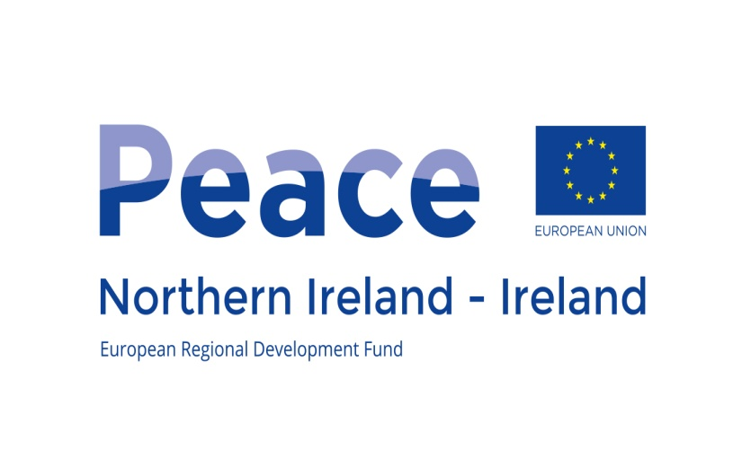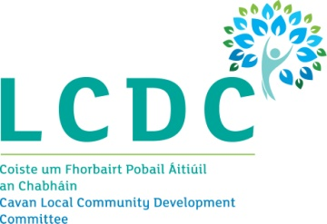
This project/initiative is supported by the EU’s PEACE IV Programme, managed by the Special EU Programmes Body.

