Townhall Cavan Scholarship Opportunity Application Form 2020

About/Vision
Townhall Cavan is delighted to announce a new scholarship award aimed at supporting three visual artists whose work explores questions and ideas that are of compelling interest to our life and times.The scholarships are aimed at research, development and exploration of artistic ideas and new work. There is no expectation for scholarships to lead to an exhibition or production. The successful artists are asked to provide an artist talk on their residency and acknowledge this opportunity in future exhibitions or publications.

The scholarships will provide the three selected artists with:

- a bursary award of €12,000
- studio space, at Townhall, Cavan for a six-month period, 2020 – 2021
We are interested in hearing from ambitious, innovative visual artists who work in any medium and can demonstrate the need, benefit, and value to their work of a scholarship at Townhall Cavan. Artists applying for these scholarships will be motivated by one of the following:

- Original, ambitious ideas on contemporary visual culture.
- County Cavan – its borders, character, cultural identity, landscape
- Natural ecology, people, environment
Selection Criteria:
To establish your eligibility for this opportunity, we will be assessing your application on the following criteria. Please ensure that you have addressed each of these criteria in this application.

- Professional practicing visual artist
- Quality of Work - original, distinctive, demonstrating ambition, fresh ideas, and relevance to contemporary visual culture
- Recent work and activity
- Quality of proposal
- Expressed and perceived need

Townhall Scholarship Application Form

Name

Address

Nationality

Telephone

Email

Website

Q1: Please give us a general description of your art practice and artistic concerns (max. 200 words).

Please type your answer below. The text box will expand.

Q2: Please tell us what you are currently working towards. This could include developing ideas for artworks, collaborations, research, commissions, and development of your work as well as finalised or realised projects and exhibitions. Please include images of what you describe here in your 8-image supporting documentation (max. 400 words).

Please type your answer below. The text box will expand.

Q3: Please give us an outline of a current artistic project and how you will carry this out using the Townhall Cavan Scholarship. (max. 400 words).

Please type your answer below. The text box will expand.

Q4: Please tell us about your art practice over the last 1-3 years. You could include ideas for projects, exhibited and unexhibited artworks, commissions, collaborations etc. Please include images of what you describe here in your 8-image supporting documentation. (max. 400 words)

Please type your answer below. The text box will expand.

Q5: Please tell us:
- why you would benefit from this opportunity at Townhall Cavan for your art practice at this time.
(max. 200 words)

Please type your answer below. The text box will expand.

Enclosures Checklist:
Please read fully and carefully the following specifications for supporting documentation.
Material and Information: Required fields/material marked *.

Completed application form

Up-to-date CV. *

Images: 8 maximum, links to videos and audio work with brief description
where necessary. Please use video hosting sites such as www.youtube.com or www.vimeo.com and include access passwords to the videos. *

Reviews and other media: 2-3 scans of recent and relevant reviews

(optional). 3 pages, max. labeled clearly as ‘Reviews and Media’.

Catalogues: Scanned copies of catalogues (optional). Pages that feature
your work only.

Additional Information (option and please specify).

If you wish to send hardcopy catalogues and books as support material to your application, they can be posted to the address below. To have your documentation returned by post, include a stamped addressed envelope with adequate postage.
We cannot take responsibility for any materials lost or damaged so please do not send publications of which you do not have extra copies.

Please note the following before returning your application form and supporting material.

Deadline: 25 August 2020
Please submit your application to ‘Scholarship Opportunity 2020’, c/o Cavan County Council Arts Office, The Courthouse, Farnham St, Cavan H12 C9K1

Please Note: All information submitted to Townhall Cavan will be held in the strictest confidence in line with GDPR guidelines and data will only be used in the context of evaluating 2020 Studio Applications. By submitting your application, you are agreeing to Townhall Cavan contacting you directly in relation to the scholarship opportunity.

Signed: |  | Date:

Please tick here if you would like to receive regular emails about arts development and opportunities in County Cavan.

Second Floor Plan Townhall Cavan

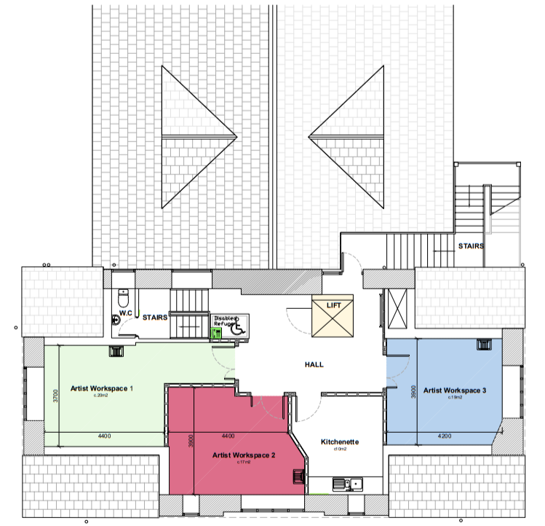

Studio 1 : Measuring 20m²

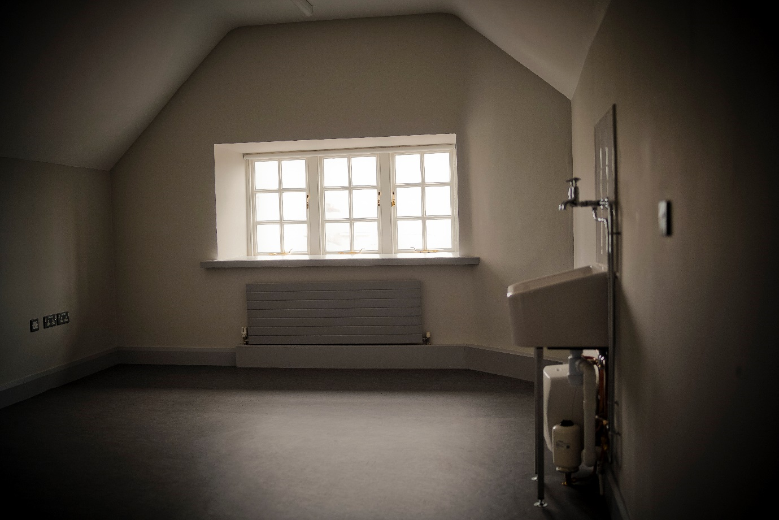

Studio 2 : Measuring 17m²

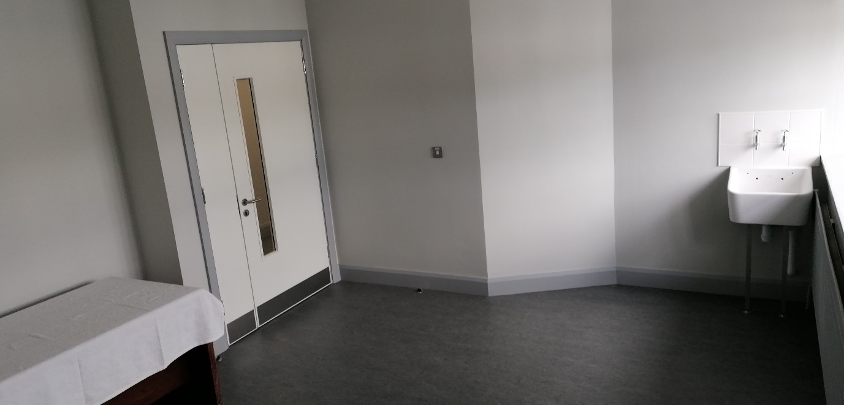

Studio 3 : Measuring 19m²

