**World Music, Dance and Physical Theatre Workshops**

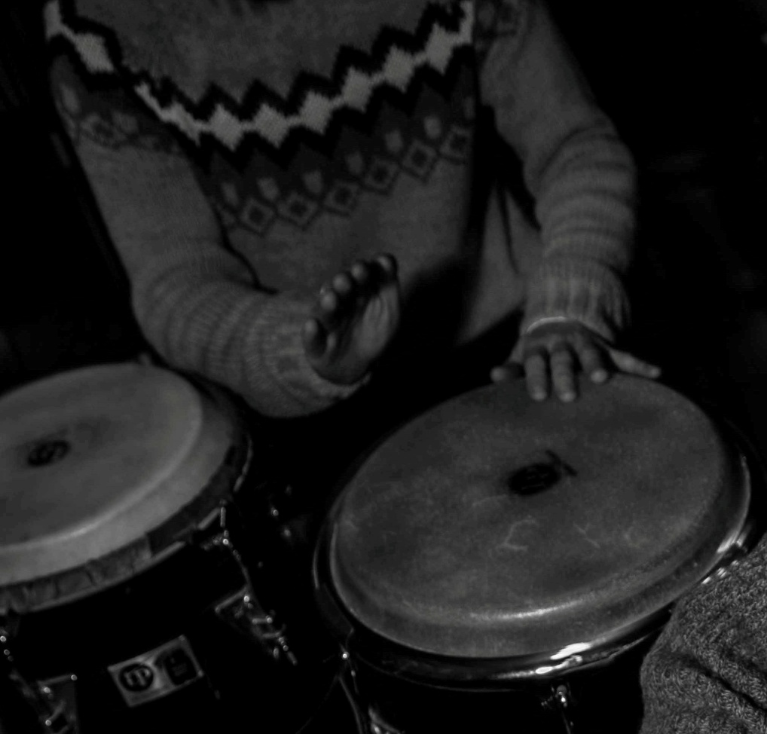

Young Arts in association with Cavan Arts Office are pleased to present a week of World Music, Dance and Physical Theatre for children from 7 – 13 years.

The programme runs from Monday 17 – Friday 21 of August from 11am – 2pm daily at the Backyard Arts Centre, Moynehall, Cavan.

Over the week the participants will explore the sounds, rhythms, stories and dances from Brazil, West Africa, Cuba and Ireland.

The music workshops feature body – percussion, hip hop beats, West African rhythms and high energy Latin and Samba music from Central and South America.

The dance and physical theatre workshop will cover modern, contemporary and folk dance, group theatre games, improvisation skills and the technique of Story Theatre.

No previous musical or dance experience is necessary and all materials and instruments are provided. Tutors Mary Farrelly, Peter Crann and Trina McCann. **Cost of Workshop €40 Deposit €20.**

Snack and drink. Suitable clothes. Booking essential by Tuesday 28 July with deposit to Cavan County Council.

049 437 8548 [www.cavanarts.ie](http://www.cavanarts.ie)

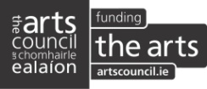  

**World Music, Dance and Physical Theatre Workshops 17 – 21 August**

**Booking Form**

Participant(s) First Name: __________________ Surname: ____________________

Age: ____________________

First Name: __________________ Surname: ____________________

Age: ____________________

Parent(s) Name: __________________ Email: ____________________

Address: __________________________________________________

Contact Number (daytime hours): _______________ Work: ________________

Mobile: _______________

Second Contact: Name: __________________ Email:_________________

Address:_____________________________________________

Contact Number (daytime hours): _______________ Work: ________________

Mobile: _______________

Heath Issues/Medical Information that we need to be aware of:

______________________________________________________________________________________________________________________________________________________

Photographs and video may be taken during the project for documentation purposes and PR, do you consent for these to be taken (Please tick if yes)

* 

**Disability/Accessibility**

Please advise us if you need special arrangements for access?

Deposit €20 per child Remainder to be paid at registration.

Cheques must be made payable to **Cavan County Council**.

Booking closes Tuesday 28 July 2015 at 4p.m.

Please post or deliver your application and booking deposit to: Cavan County Council,Cavan Arts Office,First Floor,Farnham Centre,Farnham Street, Cavan

Signed: ___________________________